Design and Implementation of the ATLAS LAr Front End Board

J. Ban, S, Negroni, J. Parsons, S. Simion, B. Sippach

Nevis Laboratories, Columbia University

Front End Board Requirements

The Front End Boards (FEBs) contain the electronics for amplifying, shaping, sampling, pipelining, and digitizing the liquid argon (LAr) calorimeter signals. The FEB electronics must read out approximately 170k calorimeter channels, and handle the signal dynamic range of about 16 bits without contributing more than 0.25% to the constant term of the energy resolution. The coherent noise per channel should be kept below 5% of the total noise. The FEB must sample the calorimeter signals at the bunch crossing frequency of 40 MHz, store the sampled signals during the Level 1 (L1) trigger latency of up to 2.5 μs, read out typically five samples per channel for each L1 trigger, and provide virtually deadtimeless operation at the maximum L1 trigger rate of up to 75 kHz. In addition, the FEBs must perform the first steps of summing in the formation of the L1 analog trigger tower sums.
In addition to these performance requirements, the FEB design must provide high channel density, low power and reasonable cost. The design provides 128 channels per FEB, with a power consumption of approximately 0.8 W per channel. Over 10 years of LHC operation, the FEBs (due to their on-detector location) must tolerate expected levels of radiation (without safety factors) of 5 kRad of ionizing radiation, 1.6 E12 n/cm2, and 7.7 E11 hadrons/cm2 with energy over 20 MeV. Finally, the limited access to the FEBs places stringent demands on reliability.

FEB Design Considerations

Block diagrams of the main functionality of the ATLAS LAr Front End Board (FEB) are shown in figures 1 and 2.
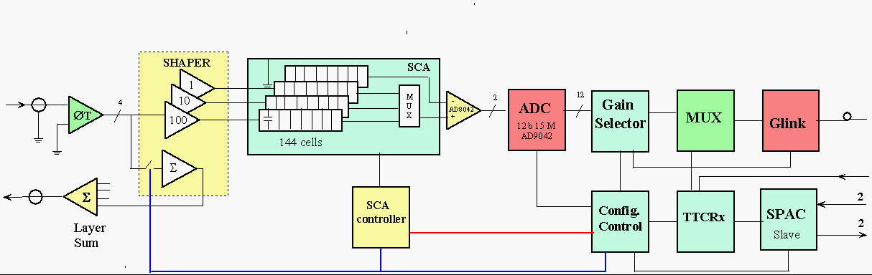

Figure 1: Block diagram depicting the signal processing for one channel of the FEB.

Figure 2: Block diagram depicting the main functionality of the entire FEB.

On the FEB, the 128 input calorimeter signals are received, amplified, split into three gain scales, and shaped with a bipolar shaping function. The shaped signals are then sampled at the bunch crossing frequency of 40 MHz, with the samples stored in analog form in switched-capacitor array (SCA) analog pipelines during the L1 trigger latency. Upon receipt of a L1 trigger accept, a train of typically 5 samples are read from the SCA and digitized by a commercial 12-bit ADC. A gain selection algorithm is applied that guarantees that all samples for a given channel and given event are digitized using the same gain scale, in order to reduce possible systematic effects. The digitized samples are formatted and then transmitted bit-serially at a rate of 1.6 Gbit/s via optical link to the off-detector Read Out Driver (ROD) for digital processing.
The FEB also provides the first levels of analog summing for the L1 trigger. Each shaper chip can sum its four input signals. These 32 sums are then summed further by plug-in Layer Sum Boards (LSB) which vary according to the section of the calorimeter in question. The LSB output sums are driven back over the crate baseplane to the Tower Builder Board or Tower Driver Board located in the same half-crate, where the summing tree is continued.

FEB Design

The 128-channel FEB is implemented as a 10-layer PCB. The full FEB schematics are available at http://www.nevis.columbia.edu/~atlas/electronics/ATLASFEB/ATLASFEB.html. A subset of the schematics is included in the final pages of this document. Figure 3 shows a photograph of the ATLAS FEB prototype.
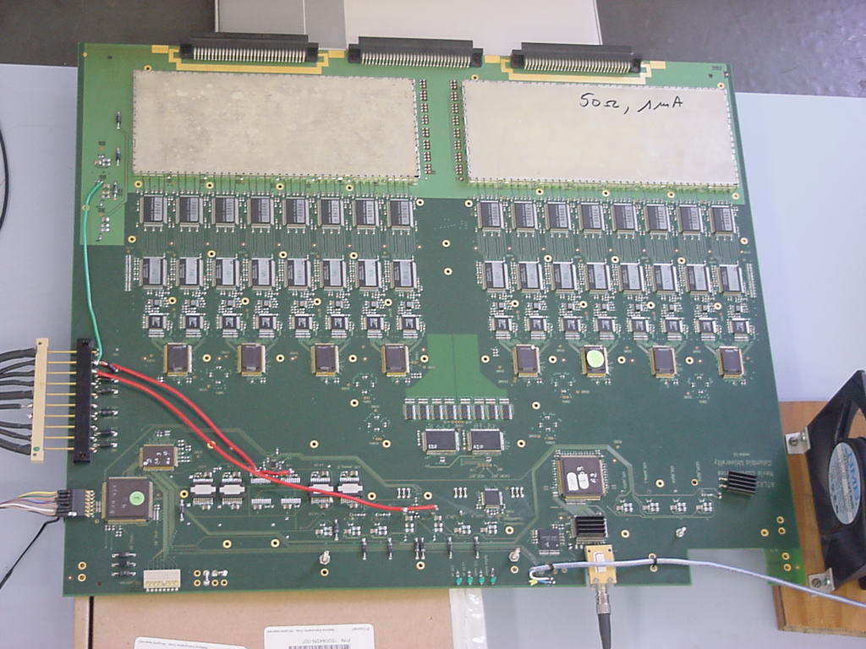

Figure 3: Photograph of the ATLAS LAr FEB prototype.

The calorimeter signals are received and amplified by four-channel warm preamplifier hybrids. The preamplifier outputs are connected to a four-channel, three-gain shaper chip which amplifies and splits each signal into three gain scales, and applies the bipolar shaping function to each scale. In addition, the shaper also sums the four channels as the first level of summing in the formation of the analog Level 1 trigger sums. Each shaper chip is followed by a four-channel SCA chip which samples the shaped signals at 40 MHz and stores the samples in analog form during the Level 1 trigger latency.
Great care must be taken, in such a high-density environment, to carefully minimize noise injected into the analog measurement by the surrounding digital logic. The preamplifiers are enclosed in dedicated Faraday shields. The general topology of the FEB layout moves progressively from the sensitive analog electronics to the digital portion of the board in order to minimize coupling. Each set of components is mounted in a single row across the FEB (along the z direction in ATLAS), and the rows of different components do not overlap. As one moves in the radial direction in ATLAS across the FEB, one encounters the row of preamplifiers, then shapers, then SCAs, then ADCs, then digital logic, and finally the digital optical link. This spatial separation reduces noise coupling into the analog electronics, and also allows the use of segmented ground and power planes.
A cross-section through the FEB is given in figure 4, showing the various functionalities performed by the different layers. Active components are mounted on both sides of the PCB in order to achieve the desired density of 128 channels per FEB. A brief discussion of the various functionalities is presented below, along with schematics of the circuitry as implemented.

Figure 4: A cross-section of the 10 layers of the ATLAS LAr FEB prototype.

Signal inputs

The calorimeter signals arrive through the Front End Crate baseplane on two of the three 96-pin DIN connectors on the signal input side of the FEB. The connectors used were chosen to mate through the baseplane with the warm cables coming from the feedthroughs, and to satisfy the small pitch required between boards in the Front End Crate. The outer two rows of 32 pins each are used for the 64 signals on each connector, with the inner row of pins used for ground connections.
The quality of the ground connection is very important for the avoidance of ground motion between the FEB and baseplane, which could be seen at the preamp inputs and amplified, contributing to coherent noise in the readout. The connectors do not provide a sufficiently high quality ground connection, due in part to the rather large inductance of the connector pins and to the assignment of one ground pin for every two signal pins. In addition, the plastic connector does not provide a shield connection which would allow a separation between signal return and ground. To address these issues, custom metal shields are used to cover both sides of the FEB connector, with mating springs on the baseplane. In addition, additional ground pins are used to further improve grounding between the FEB and the baseplane.

Analog Signal Processing Chain

From the input connectors, the signals are routed to the inputs of the four-channel preamplifier hybrids. The signals are routed on two inner layers, each surrounded by ground planes, to avoid pick-up. In addition, the use of two layers allows the routing without signal crossings to avoid cross-talk. The preamplifiers are enclosed in their own RF-gasketed Faraday shields to provide additional noise immunity.
The preamp outputs are routed directly to the inputs of the four-channel shaper ASICs, which split the signal into three gains and provide fast bipolar shaping. In addition, the shapers provide analog sums of the four channels on a single chip as the first stage of formation of the Level 1 trigger sums.
The 12 shaper signal outputs (4 channels times 3 gains) are routed directly to the inputs of the SCA analog pipeline chip. One SCA analog memory chip handles the signals for all three gains of four different calorimeter channels, and also provides a differential reference pipeline for each channel. It therefore contains a total of 16 pipeline channels. The reference channels are connected to a dummy output of the shaper chip. The use of a single SCA for four channels provides an ideal match to the four-channel three-gain shaper chip (which in turn matches the four-channel preamplifier hybrid). This allows a compact layout with short signal traces, and avoids potential problems in cross-talk and signal trace loads which could result if a more complex routing of signal traces over several signal layers were necessary.
A pair of SCA chips (ie. a total of 8 channels), mounted on opposite sides of the PCB, share a single 12 bit ADC. The ADCs are operated with a continuous 5 MHz clock which is derived from the 40 MHz input clock. A fixed voltage divider is used to set the DC offset to match the SCA output to the ADC input signal range. Data from two ADCs is received by a single Gain Selector.
To reduce the required rate of digitization and the amount of data to be read out, only one gain scale will usually be digitized per channel and event. Reconstructing the pulse height for a given channel from samples digitized on different gain scales would be susceptible to systematic effects such as those due to different shaping times on different scales. To avoid this, a gain selection algorithm is applied which guarantees that all samples for a given channel and event are digitized using the same scale. The Gain Selector is responsible for performing the channel-by-channel gain selection by controlling the gain selection lines running back to the 4 SCA chips to which it is connected. Using an FPGA allows a variety of gain selection algorithms to be investigated. In ATLAS-style running, one would first digitize the sample near the peak on the Medium gain. The Gain Selector then compares this value with two 12-bit thresholds which are downloaded individually for each channel, in order to choose the optimal gain for that event. All samples are then digitized for this channel using the selected gain scale. This algorithm implies the digitization of six samples per channel if five are finally required, since the original peak testing sample is not used in the final processing. This inefficiency, however, removes the need for dedicated analog hardware (such as a fast comparator) for making the gain selection.
For inter-calibration or testing, it is possible, by appropriately configuring the Gain Selectors, to digitize multiple gain scales for all channels (albeit at a slower trigger rate), or to ``force'' the selection to any particular gain scale for any channel. It is also possible to digitize up to 32 samples per channel, in order to digitize and read out the entire waveform. This allows a measurement of the drift-time, which can be used to monitor temperature and other variations which would contribute to the constant term in the energy resolution.
The Gain Selector also formats the data for transmission to the ROD. The Gain Selector inserts into the ADC data stream the header, control words, and trailer. Some of the control information, such as the Bunch Crossing Number and the SCA addresses, is transmitted to the Gain Selectors from the SCA Controller which interfaces with the TTC and performs the address bookkeeping. The Gain Selectors also calculate and insert parity bits into each 16-bit data word they produce, to allow single-bit data transmission errors to be detected at the ROD.

TTC Interface

The 80 MHz encoded TTC signal is received on the FEB and decoded via the on-board TTCRx chip. The TTCReady signal is connected to an LED on the FEB front panel to provide a visual indication of whether the TTCRx is properly locked on the input TTC signal.
The 40 MHz TTCRx output clocks (CLK Deskew 1 and Deskew 2) are fanned out to operate the various components on the FEB. The L1 Accept, Bunch Counter Reset (BCR), and Event Counter Reset (ECR) signals are transmitted to the SCA Controllers. A TTC broadcast command can be used to reset the SCA Controllers.
The TTCRx is connected via its I2C port to I2C port 0 of the SPAC Slave, allowing the TTCRx to be configured and Reset via SPAC.
For more details, see the TTCRx interface schematic near the end of this document.

Clock Fanout

The clock fanout of the FEB employs a total of 7 CLKFO chips, a block diagram of which is shown schematically below. The first CLKFO in the fanout provides several functions: it clips the CLK Deskew 2 signal to form the WCLK for the SCA buses; it counts down the CLK Deskew1 with a triple-redundant counter to form the basic 5 MHz CLK for the FEB, and it provides some fanout. The remaining 6 CLKFO chips are used to provide the necessary fanout for both the 40 MHz and 5 MHz CLKs. More details can be found on the schematic of the clock fanout, shown later.

SPAC Interface

Each FEB is connected via a bi-directional SPAC serial control link to a ``SPAC Master'' module which is located in an external VME crate. The serial links of the various FEBs are bused within a front-end crate. Control data required to configure the FEB for data taking are transmitted to the FEB through this link. It is also possible to read back and verify these parameters using the same link.
The SPAC Slave chip provides the interface with the SPAC bus. Configuration of the various devices on the FEB is managed via the Config Controller, which interfaces to the parallel interface of the SPAC Slave. The TTCRx chip is connected to the SPAC Slave I2C port 0, and the two DCU chips are connected to the SPAC Slave I2C port 1.
The various types of data to be loaded to (and/or read back from) the FEBs include setting the switches on the Shaper chips which enable/disable the contributions from the individual channels to the Level 1 analog sums, downloading the parameters to configure the SCA Controllers (such as the L1 latency, the number of samples to digitize, and the order of digitization), downloading the parameters to configure the Gain Selectors (such as the number of gains to digitize, the order of digitization, and the thresholds to be used in the gain selection), and monitoring various voltages and temperatures on the FEB via the DCU chips.
The schematic of the SPAC and Config Controller interface is shown in the schematic later.

Data transmission

The system is completely data-driven, with all necessary control information (such as event headers, bunch-crossing numbers, etc.) accompanying the data, having been inserted into the data stream by the Gain Selectors. Parity information is also included in the data to allow the detection of transmission errors.
Output data is produced by the FEB in 32-bit words at 40 MHz. The data from the various Gain Selectors is multiplexed via the MUX chip, the output of which is 16-bit words at 80 MHz. These data are then bit-serialized by a commercial GLink chip, which also adds control and framing bits. The final serial data stream of 1.6 Gbit/s is converted to optical by a custom Optical Transmitter module and then transmitted via optical fiber to the off-detector ROD. For details, see the schematic of the optical link interface included later.

Power distribution

Power is brought to the FEB on the 10-conductor power bus in the Front End Crate. Each voltage is locally regulated on the FEB. The voltages used, and the currents drawn for a single FEB, are summarized below**. The total power dissipation for a single FEB is approximately *** W, or *** W per channel.

Input voltage Rail | Current (Amps) | Power (Watts)
+6V digital | 2.50 | 15.0
+11 V | 0.27 | 3.0
+6V analog | 4.27 | 25.6
+4 V | 3.63 | 14.5
-4 V | 5.15 | 20.6
-7 V | 0.17 | 1.2
Total |  | 79.9

A total of 20 voltage regulators (Vregs) are required for each FEB, 14 of which are for positive voltages with the remaining 6 for negative voltages. The regulators are essential for a variety of reasons, including providing the many different voltages needed on the FEB, providing protection against faulty power supply voltages, over-current protection, and noise immunity.
Separate schematics included later show the distribution of regulators for the preamps and shapers, and for the SCA and the digital part of the FEB.

Grounding issues

The quality of the ground on the FEB and of the ground connection between the FEB and baseplane are critical for achieving the demanding performance requirements.
**moe information to come.

Voltage and Temperature Monitoring

Two DCU chips, one mounted on each side of the FEB, are used to monitor several of the voltages. In addition, the DCU chips can be used to measure their own temperatures as well as the temperature of one external thermistor each. One thermistor is mounted on the top side of the FEB in a location between the GLink chip and TTCRx. The other is mounted on the bottom side of the FEB in a location near some of the voltage regulators.
More details can be found on the monitoring schematic included below.

